**MOBILE MARKETING WEB**

**APPLICATION STYLE GUIDE**

**Table of Content**

Introduction 4

Typography 5

Logotype 7

Colors 9

# Introduction

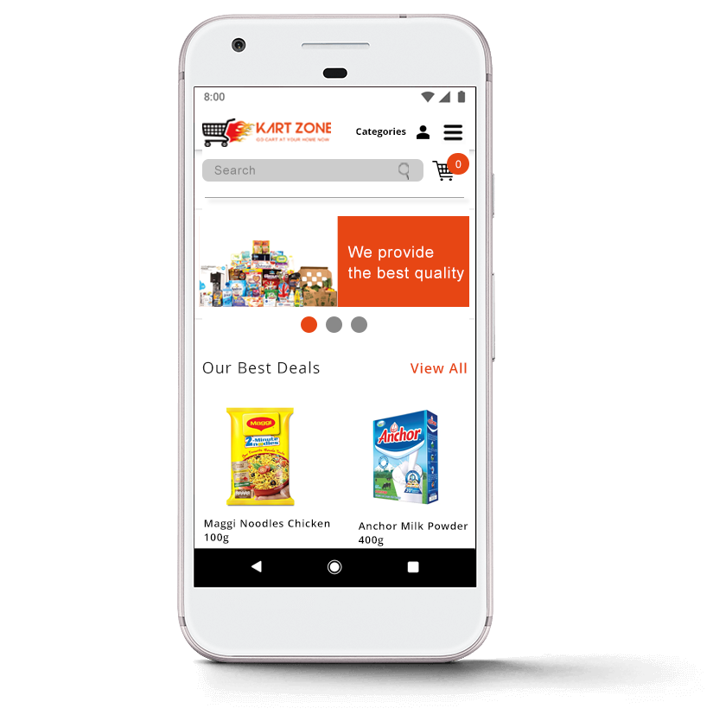

Kart Zone introduced another technology for launching the web app by an online supermarket in Sri Lanka.

With this new web app customer can order the goods via the online web app by view on going Saver promotions

As well as Cyber weekend promotions, contact us and send in any comment or suggestions they may have.

# 

# **Typography**

# **Typography Settings**

**1.     Headline: Open Sans Bold**

Font size mobile: 24px and up

Line height mobile: 120%

Font size tablet: 32px and up

Line height tablet: 90%

Text: upper case

Letterspacing: 0

Color: #000000

**2.     Subheadline: Open Sans Semibold**

Font size mobile: 9-16px

Font size tablet: 10-18px

Line height: 120%

Text: upper and lower case

Letterspacing: 0

Color: #5c5c5c

**3.     Bodycopy: Open Sans Regular**

Font size mobile: 9-16px

Font size tablet: 10-18px

Line height: 160%

Text: upper and lower case

Letterspacing: 0

Color: #383838

**4.     Labels: Open Sans Light**

Font size mobile: 9-16px

Font size tablet: 12-18px

Text: upper case

Line height tablet: 120%

Letterspacing: 0

Color: #7d7d7d

**Typography Justification**

Within the mobile application Open Sans font type is used to make the content within the application more readable and to look modern and classy.

Open Sans Bold is used for the headlines to emphasize the headline and Open sans semi bold is used for the sub headlines to emphasize the sub headlines. Open sans light is used for the labels as it expresses clean and neat mood. For the bodycopy open sans light is used to make the content easy to read for any person. This font type is also readable for the visually impaired person.

**Header1**

**Header2**

Header3

Header4

# Logotype

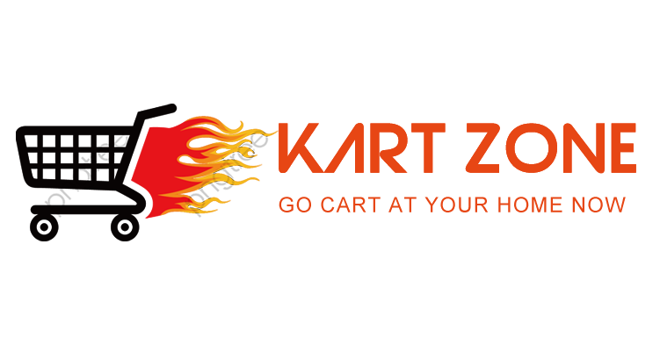

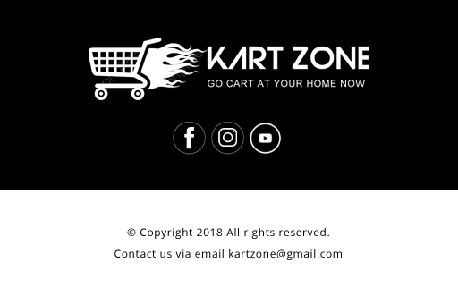

Colours

Black

#000000

R:0 G:0 B:0

Orange

#e74614

R:231 G:70 B:20

Green

#00b050

R:0 G:176 B:80

Red

#bf0000

R:191 G:0 B:0

Light Grey

#7d7d7d

R:125 G:125 B:125

**Success Messages**

**Warning Messages**

Grey

#5c5c5c

R:92 G:92 B:92

Dark Grey

#383838

R:56 G:56 B:56

White

#ffffff

R:255 G:255 B:255